DATA LOADING IN SNOWFLAKE

COPY COMMAND
Let’s do hands on COPY COMMAND
Create external stage pointing to files at AWS location
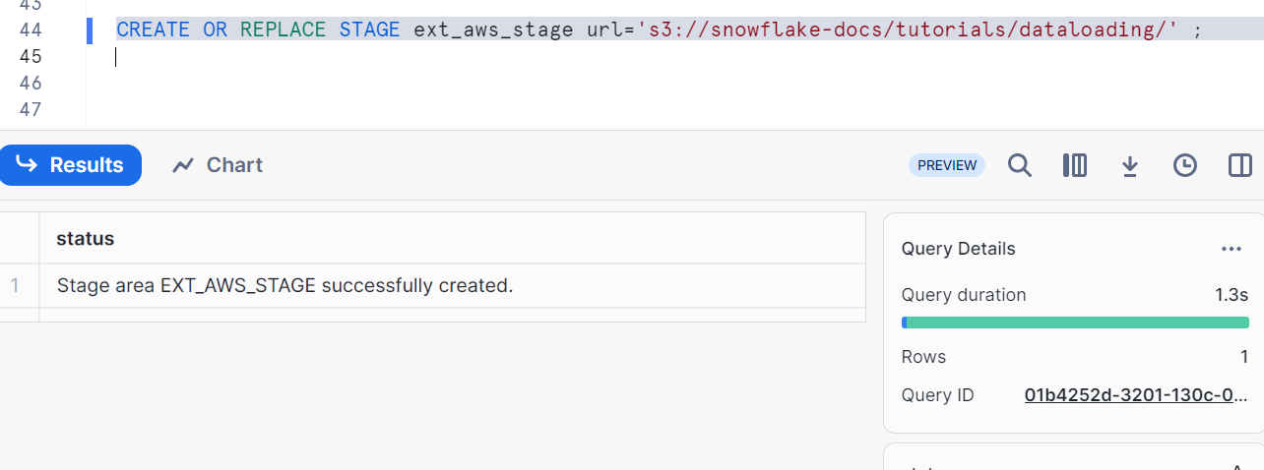
List the Stage. It shows the files.
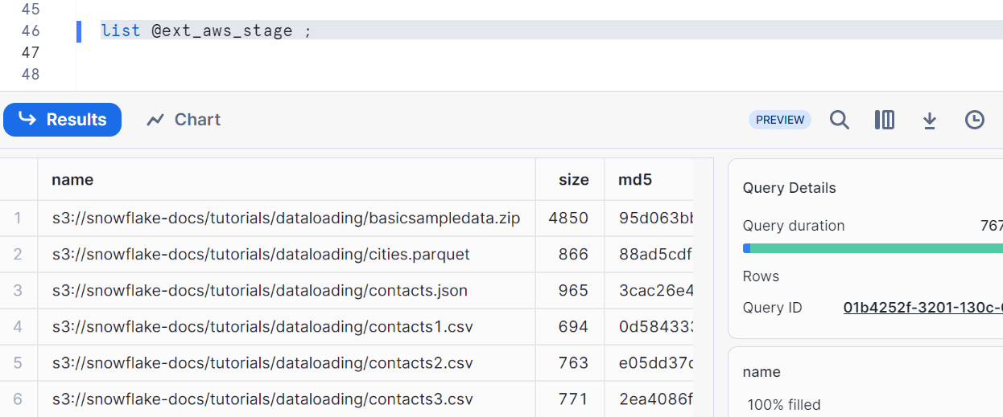

Create a table to load the files. The tables should have exact number of columns as files
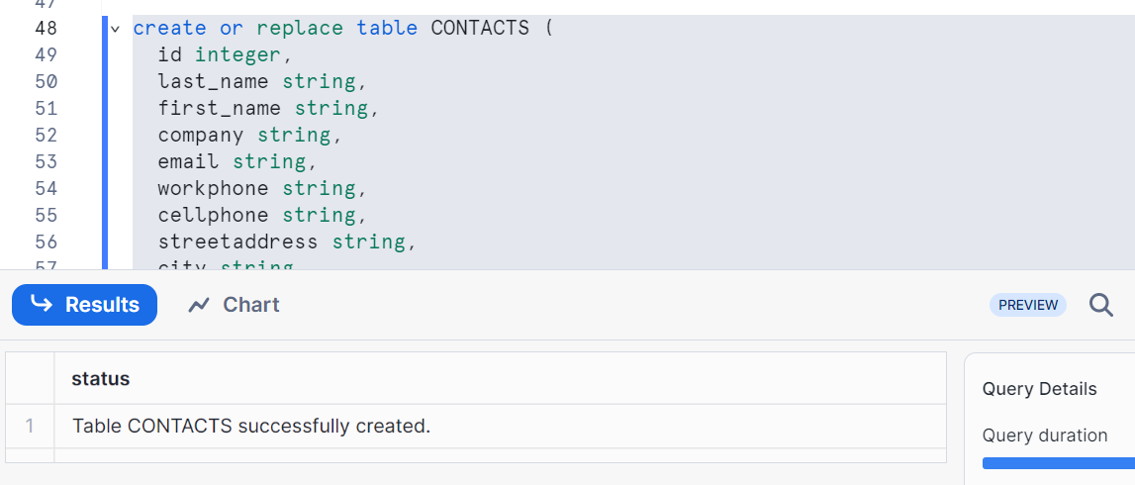
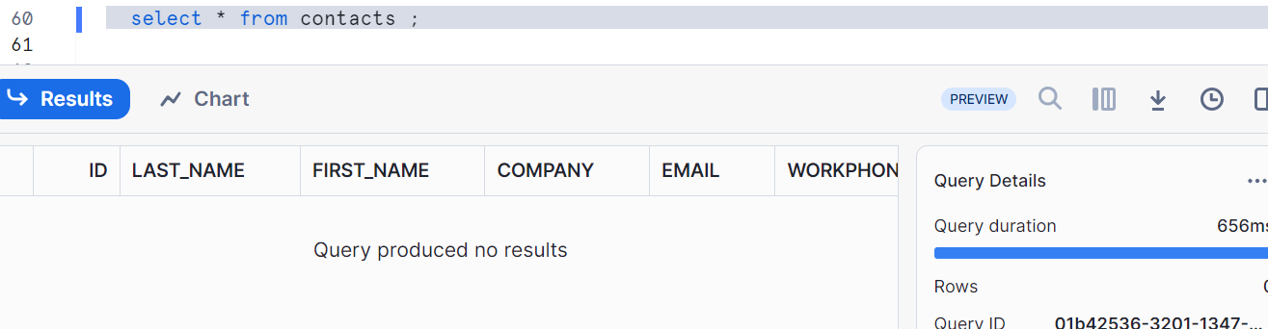
If you are working in the same database/schema then no need to qualify the external stage (e.g. @ext_aws_stage), otherwise – qualify (@DB_name.schema_name.stage_name)

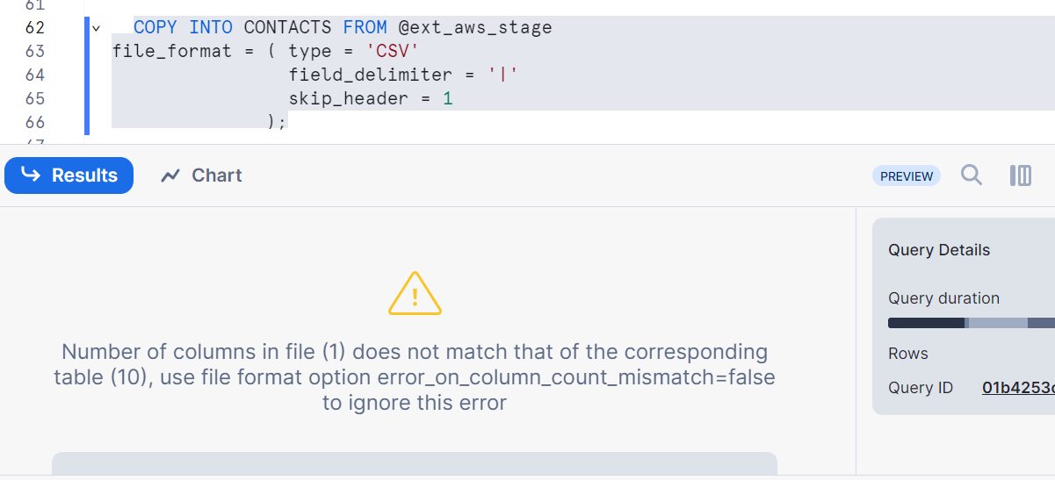
In above image we are getting error as copy command is not able to understand which file to load as we have multiple files in the external stage. Suppose if we had only one file and if column names matches with the table column names, then it might take

Hence to load the file, give the Files to load specific file
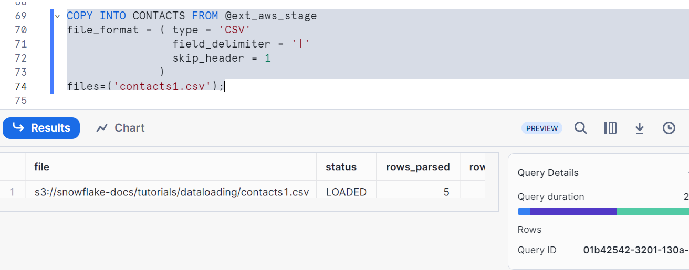
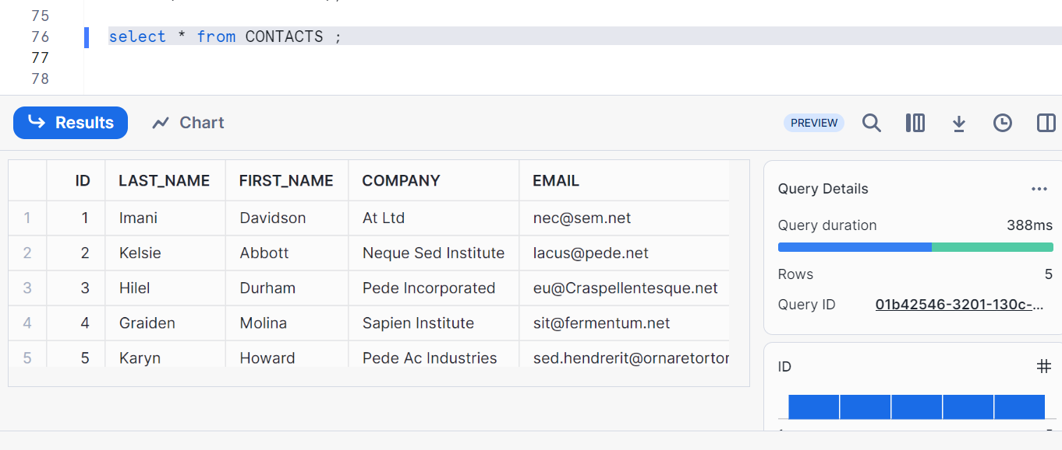

Rerunning the same command to load again, but snowflake skips it as it maintains in the Meta data that this particular file is already copied or loaded to the contacts table
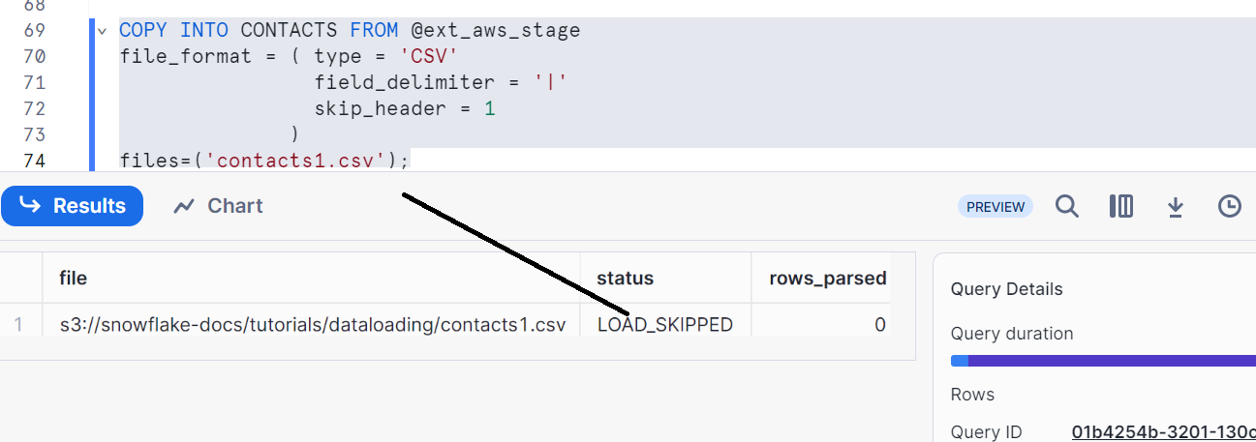
But what can you do if you want to return the command and load it?
Let’s try to delete the table first
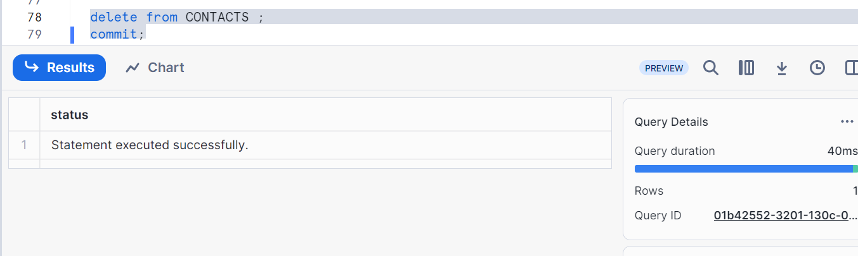
Rerunning command
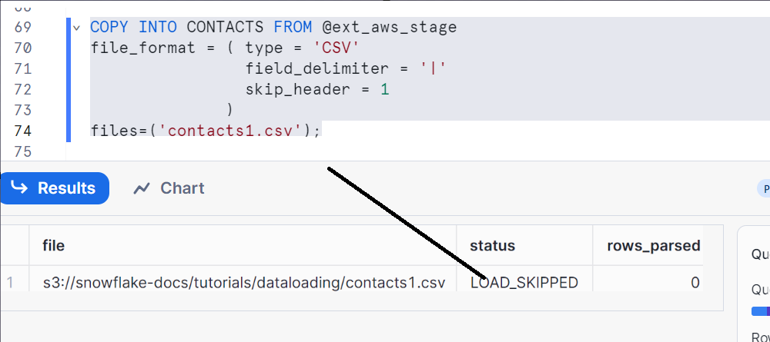
So when you are deleting the data from a table and rerunning it, the Meta data is not getting reset and snowflake will again skip the load

Therefore in order to load the table again, truncate it and then load
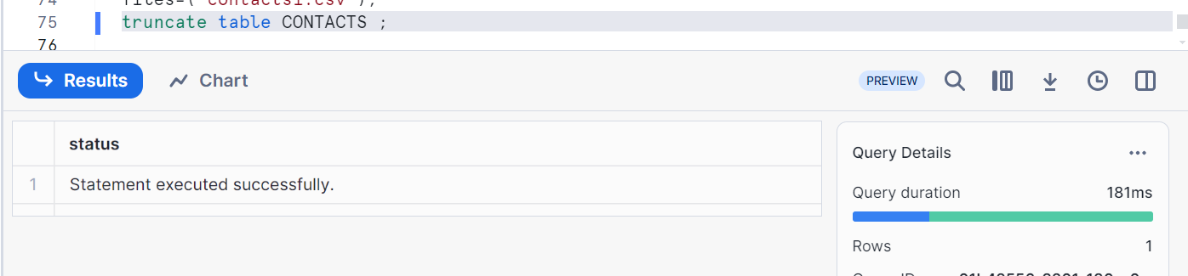
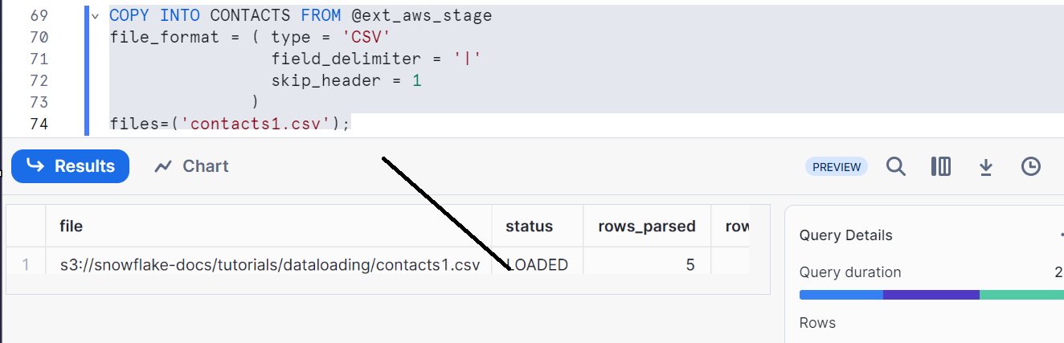
Loading more than one specific file
First let’s truncate the table
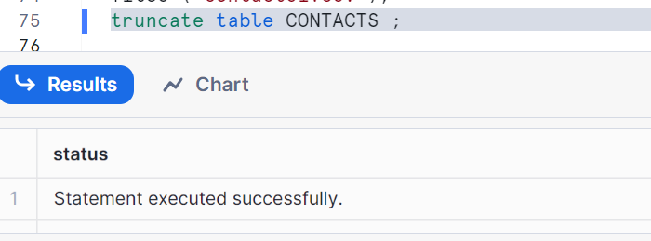

Now load it
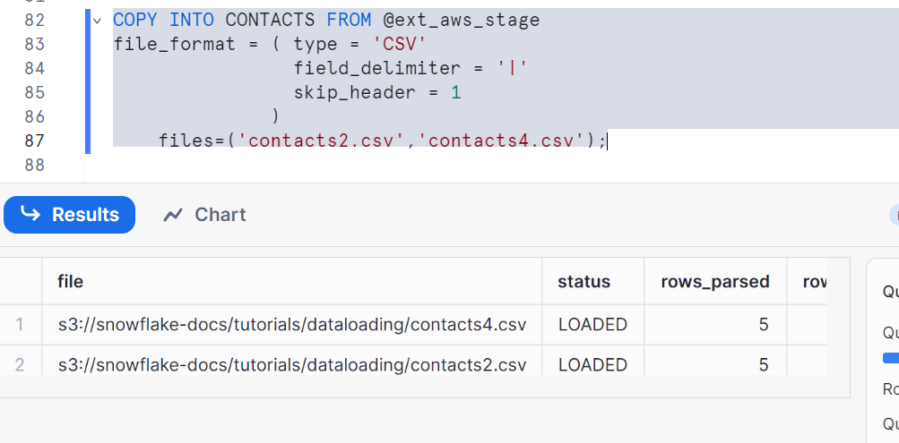
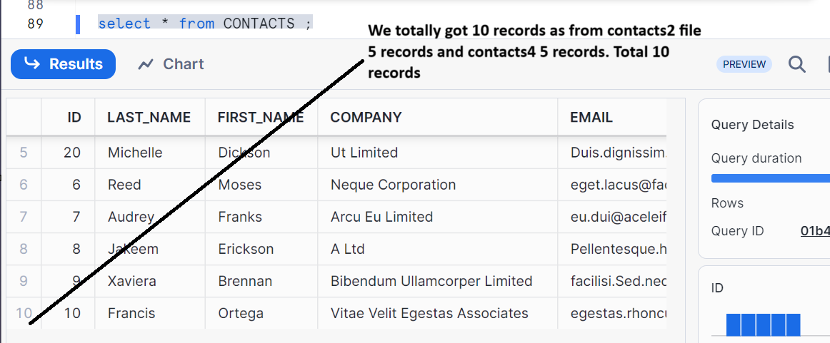

Let’s do the same thing with help of patterns
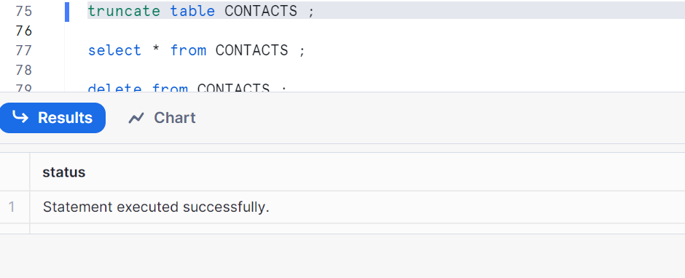
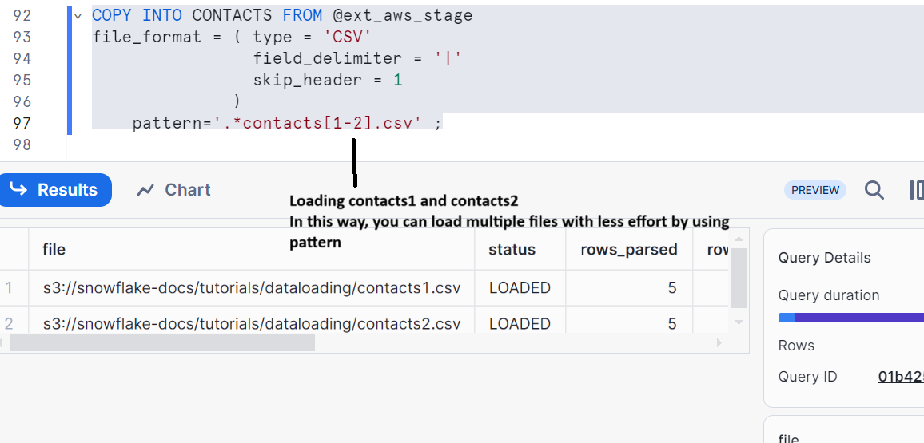
Make sure that all those files have same number of columns as we have in our table
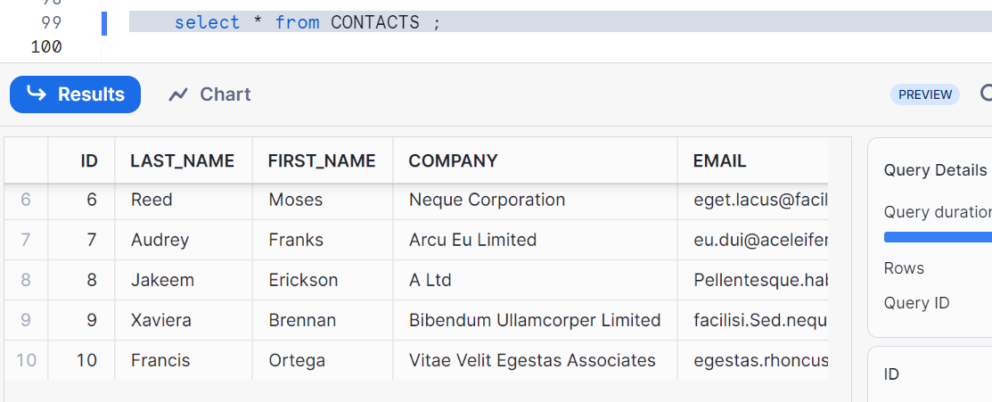
Cleaning up
